Task 2 - Multilingual Agrotbot
Name: Tanvi Khicchi
1. Register Page
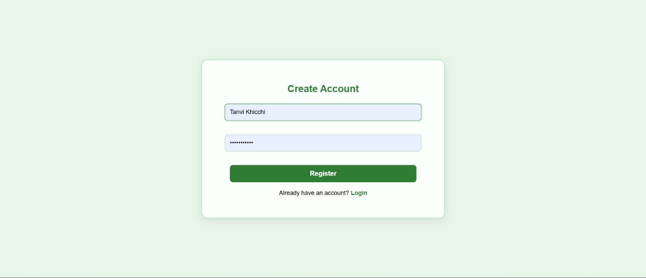
User registration interface for new users.
2. Login Page
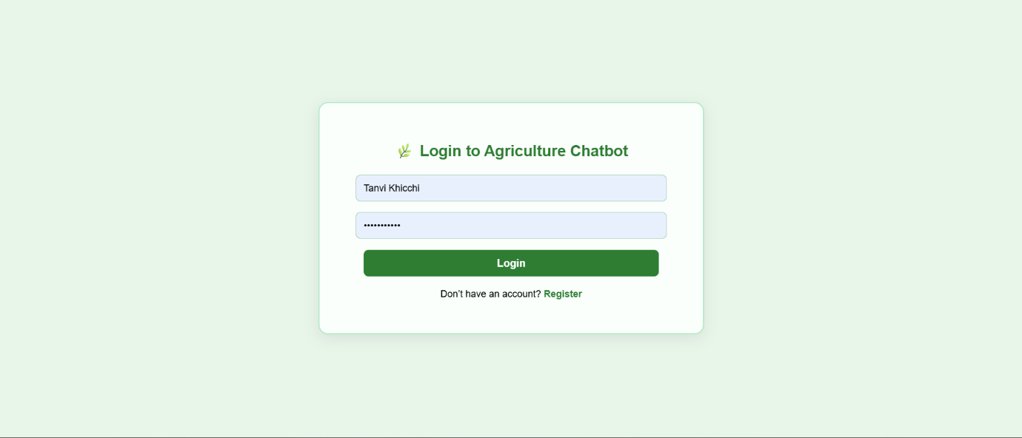
Secure login for existing users.

3. Chatbot Interface - Multilingual Support
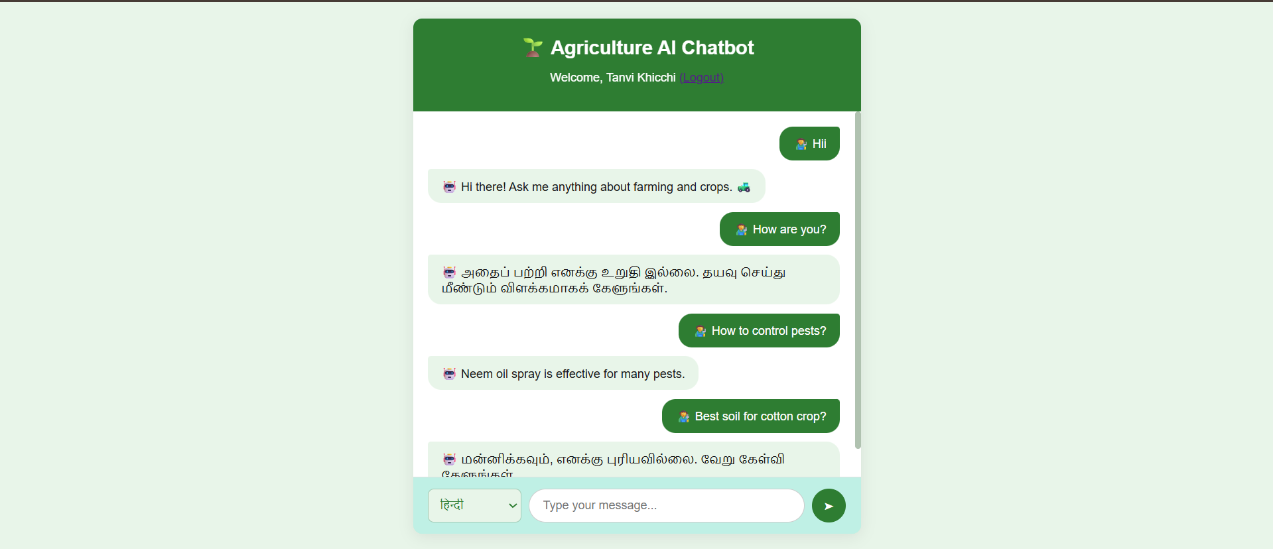
Allows users to interact with the chatbot in both English and Hindi, making the platform accessible and user-friendly for farmers across different regions.

